Initial client meeting minutes
Present:
Edward davey
Spencer Mason-Morgan
Suncheon prince
Ethan Jackson

Shubas paudyal

Getting to know people

Our understanding of the project – scalable inventory system, forecasting supply and demand. Scalable to different storage system taking into account expiry and best ways to reduce loss.
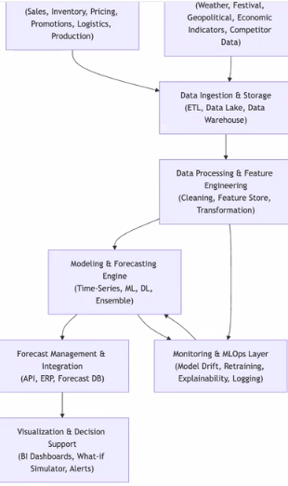
These are some flowcharts shown by shubas, talking us through the project.

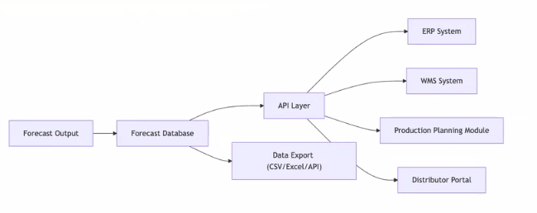
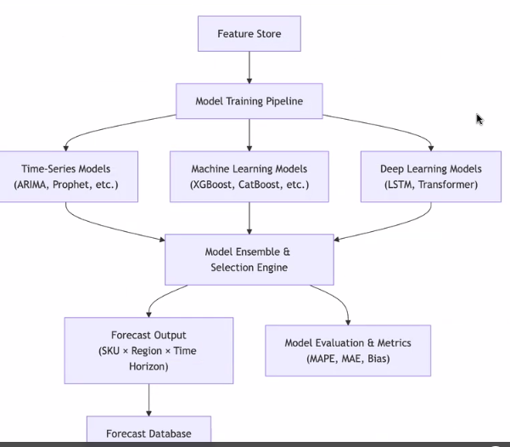

After showing us this we discussed the ide to use: VS code.
“Where to start?” scoping the project, scrum – already using a trello(added client to the board).
Also added to the GitHub account.
“Where to access some test data?” should be some on a sandbox account on the aws, if this cannot be done then some can be obtained by the client
Next meeting, ~ two weeks’ time
Acquired shubas paudyals watsapp as well +977
End of meeting

